**Power BI Major-Project Documentation**

**Title**

* Project Title: OTT Platforms Data Analysis
* Name: Shamshunnisa M
* Date: [Submission Date]

**1. Project Overview**

* **Objective**: To analyse all aspects of different OTT platforms and their growth.
* **Dataset**: 3 platforms data (Netflix, Amazon Prime, Disney + Hotstar) from different platforms in .csv files with 7-8 rows in each dataset.
* **Tools Used**: Power BI

**2. Steps Involved**

1. **Data Import**:
   * I downloaded data from Kaggle & GitHub reference and imported .csv file to power BI.
2. **Data Transformation**:
   * Firstly, I cleaned all the null values and then there were some missing columns in data so I added columns and created some extra values. Removed duplicates.
3. **Visualization**:
   * Pie chart
   * Stacked Bar Chart
   * Donut chart
   * Flash Cards
   * Slicers
4. **Dashboard Design**:
   * I aligned all charts in a sequence that reader can read all things mentioned properly and to mention some specific numbers I included some cards.
   * As well I added some filters so that user can see data which he required.

**3. Key Insights**

* **Netflix:**
* Netflix's 15K content pieces are mostly movies (12K), with series gaining awards momentum post-2016, though movies have won more awards overall.
* Viewer preference leans toward longer movies, with "R" ratings dominating at 45%, reflecting a mature audience focus.
* **Amazon Prime:**
* Amazon Prime Video hosts 9684 shows, mostly movies (7814), with the U.S. dominating content distribution at 93.06%.
* Viewer ratings lean toward 13+ (29.59%), while Indian content remains a smaller slice at just 2.61%.
* **Disney + Hotstar:**
* Disney Hotstar offers 1450 shows, mostly movies (1052), with a solid average IMDb score of 6.8, and a focus on diverse content genres.
* Viewer ratings are led by TV-14 and TV-PG, showcasing family-friendly programming with notable yearly additions from 2019 to 2021.

**4. Screenshots:**

* **Home page:**

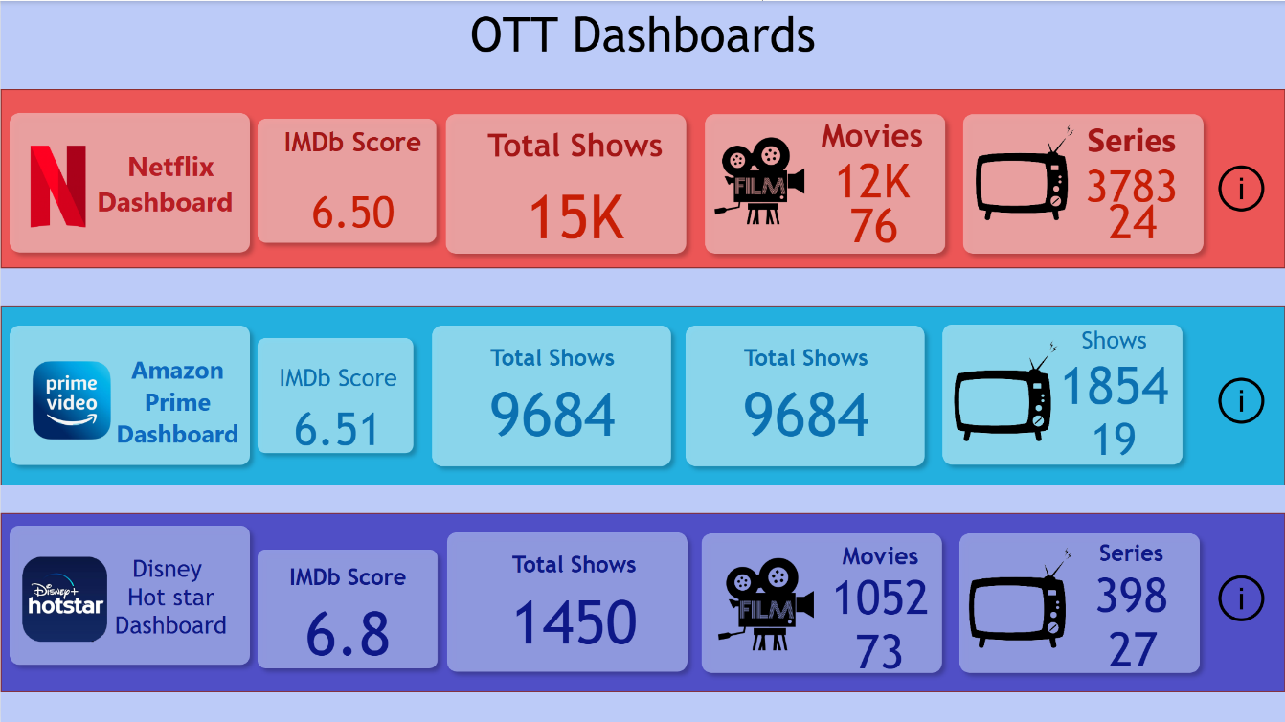

* **Netflix Full Insights Dashboard:**

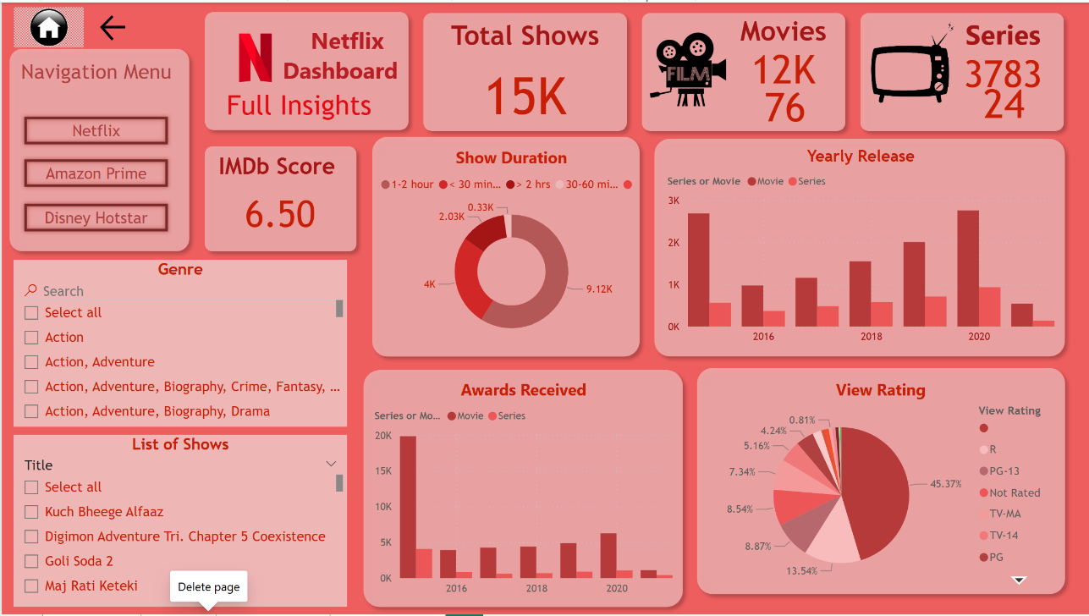

* **Amazon Prime Full Insights Dashboard:**

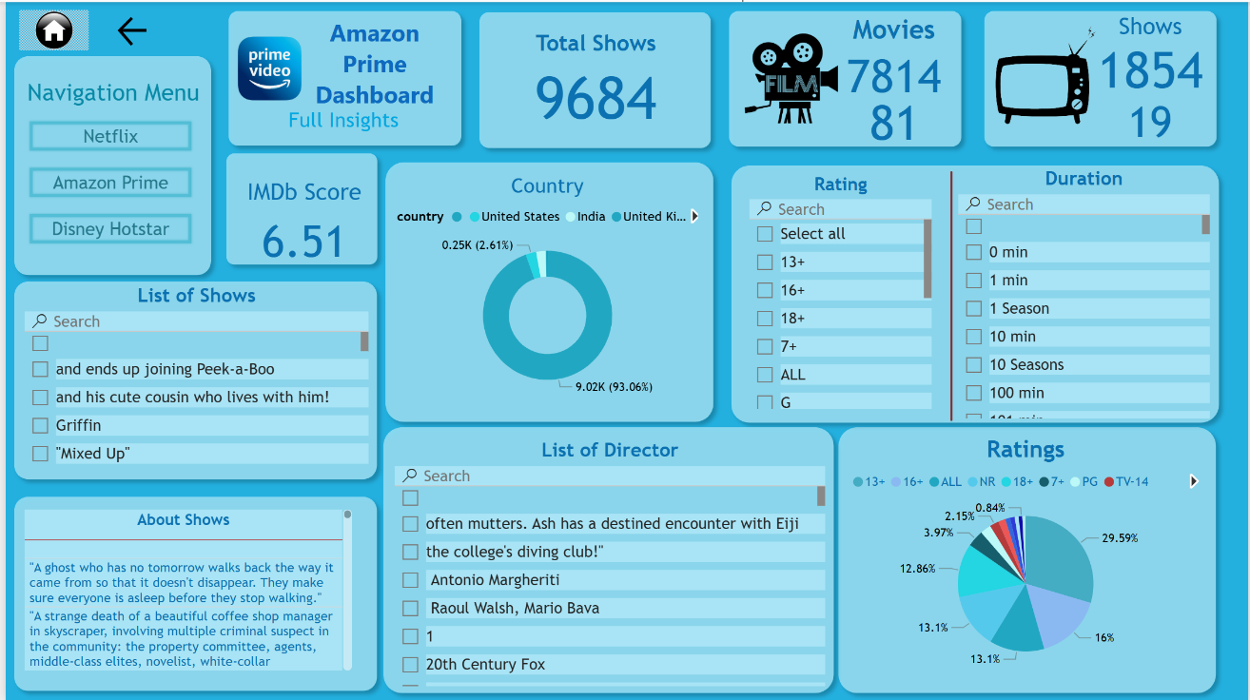

* **Disney + Hotstar Full Insights Dashboard:**

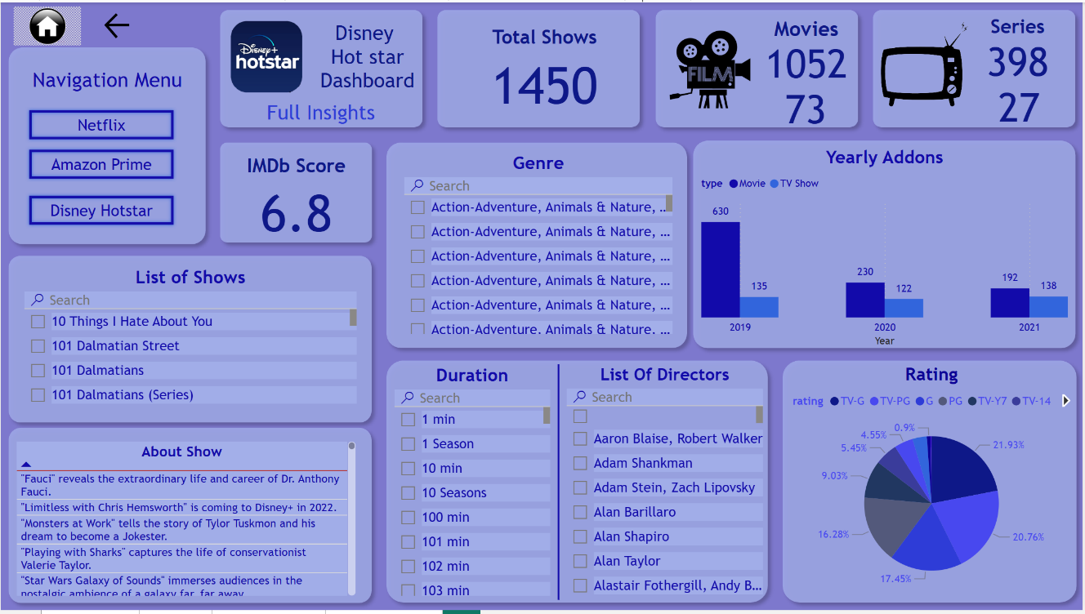

**5. Conclusion**

1. **Netflix**: Offers the largest catalogue (15K shows), focusing on movies and mature-rated content, with steady annual releases and diverse genres.
2. **Amazon Prime Video**: Features 9684 shows, with a significant U.S. focus and a high proportion of 13+ rated content.
3. **Disney Hotstar**: Provides 1450 shows, emphasizing family-friendly programming, high IMDb scores, and consistent content growth in recent years.
4. **Overall Insight**: Each platform caters to distinct audience preferences, securing unique positions in the OTT market.